CERTIFICATE

This is to certify that Mr. Raghav Gupta has partially completed / completed / not completed the Semester Training during the period from 12th Jan 2026 to 12th Jun 2026 in our Organization / Industry as a Partial Fulfillment of Degree of Bachelor of Technology in Computer Science & Engineering.

(Signature of Project Supervisor)

Date: __________________

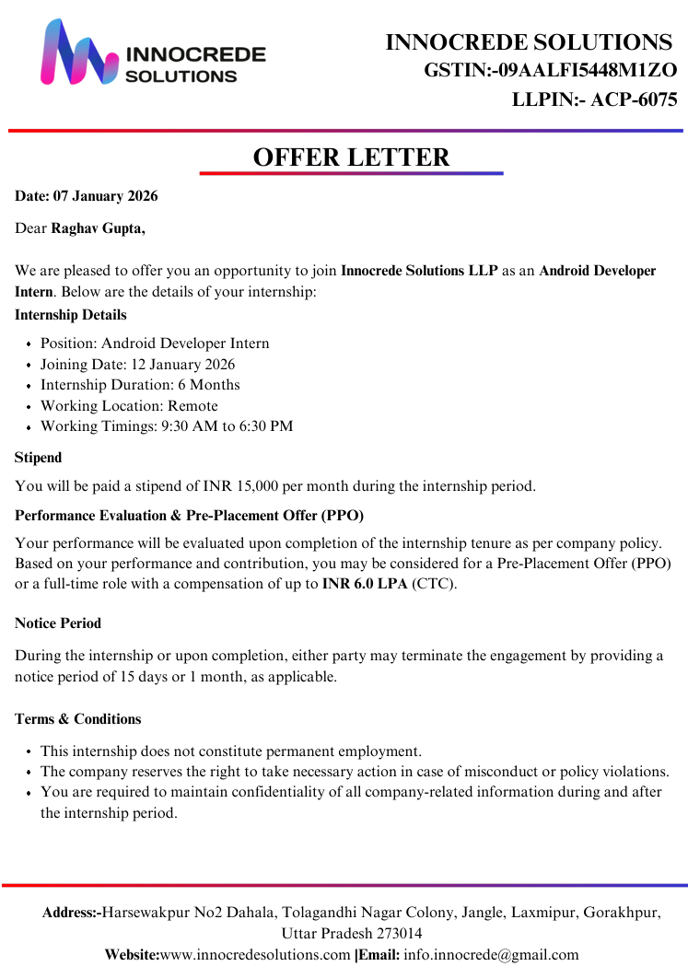

CANDIDATE DECLARATION

I hereby declare that the Project Report entitled "Meet Recap" is an authentic record of my own work as requirements of 8th sem academic during the period from 12th Jan 2026 to 12th Jun 2026 for the award of degree of B. Tech. (Computer Science & Engineering, Chandigarh Engineering College- CGC, Landran, Mohali under the guidance of (Mr. Amandeep Ummat).

Raghav Gupta

Date: ____________________ 2337724

Certified that the above statement made by the student is correct to the best of our knowledge and belief.

Signatures

Examined by:

1. 2. 3. 4.

Head of Department

(Signature and Seal)

ACKNOWLEDGMENT

I take this opportunity to express my sincere gratitude to the Dr. Sukhpreet Kaur (Director- Principal Chandigarh Engineering College, Landran & HOD CSE) for providing this opportunity to carry out the present work.

I would like to expresses my gratitude to other faculty members of Computer Science & Engineering department of CEC, Landran for providing academic inputs, guidance & Encouragement throughout the training period. The help rendered by Mr Amandeep Ummat & Mr Sachin Supervisor for Project is greatly acknowledged. Finally, I express my indebtedness to all who have directly or indirectly contributed to the successful completion of my semester training.

ABOUT COMPANY

As a final semester student pursuing a degree in Computer Science & Engineering, I had the opportunity to gain valuable industry experience through a Six-month Semester Training program with Innocrede Solutions LLP.

During my internship, I gained hands-on experience in mobile application development along with exposure to modern full-stack development practices. My major project, titled MeetRecap, is a login-first multi-user video meeting Android application designed for real-time communication, live captions, and automated meeting recap generation.

The application enables users to create or join meetings, communicate via video and audio, exchange messages through real-time chat, and generate downloadable meeting recap PDFs after each session. It also integrates browser-based speech recognition to provide live captions in both English and Hindi, enhancing accessibility and usability. Additional features such as screen sharing and microphone/camera controls further improve the overall meeting experience. In essence, MeetRecap is a WebRTC-based meeting platform that combines real-time communication with transcription and recap generation capabilities.

The successful development of this project required consistent independent effort, problem-solving, and practical implementation of concepts learned during training, extending beyond regular training hours.

Innocrede Solutions is a full-stack digital consulting company that helps brands build high-performance websites, applications, and digital campaigns. The company focuses on delivering scalable, user-centric solutions by combining strong product thinking with modern engineering and design practices.

The organization emphasizes innovation, quality, and performance while working closely with clients to understand their business needs and transform ideas into impactful digital products. With expertise across multiple domains, Innocrede Solutions delivers solutions that are efficient, reliable, and aligned with current industry standards.

Services Offered: IT Consulting, Full-Stack Web Development, Custom Application Development, UI/UX Design, Digital Product Strategy, Mobile Application Development, Software Testing & Quality Assurance, and Digital Marketing Solutions.

ABSTRACT

MeetRecap is a real-time video meeting application developed to provide an interactive and efficient communication platform for users. This Android-based application enables multiple users to connect in virtual meetings with features such as video/audio communication, real-time chat, and live captioning. The system is designed to enhance online collaboration by integrating modern communication technologies with intelligent recap generation.

The application uses Firebase Authentication to provide secure user login and registration functionality. It also utilizes Firebase Realtime Database/Firestore to store and synchronize real-time data such as user information, meeting details, and chat messages, ensuring seamless communication between participants. Users can create or join meetings through a secure login system and interact using video and audio streams, along with real-time messaging and screen sharing capabilities.

A key feature of the system is its live speech-to-text functionality, which is primarily powered by the browser-based Web Speech API. This enables real-time caption generation in both English and Hindi, improving accessibility and user engagement. Additionally, the system incorporates Vosk as an offline fallback mechanism, ensuring that speech recognition remains functional even in limited or no internet conditions.

One of the major highlights of the project is the automatic generation of meeting recap reports in PDF format after the session ends. Furthermore, the generated PDF is automatically sent to the registered email addresses of the participants, allowing users to easily access and review meeting discussions at any time without manual effort.

The system follows a distributed architecture where real-time communication is handled using WebRTC technology, while backend services manage authentication, data storage, and synchronization. The application ensures secure data handling, efficient communication, and reliable performance across multiple users.

Various modules such as user management, meeting management, real-time communication, caption generation, and report generation are integrated to provide a seamless and user-friendly experience. The project emphasizes scalability, performance, and usability while adhering to modern software development standards and practices.

Table of Contents

CONTENT PAGE NO.

Certificate .........................................................................................................................i
Candidate Declaration .....................................................................................................iii
Acknowledgement ..........................................................................................................iv
About Company ...............................................................................................................v
Abstract ...........................................................................................................................vi
Table of Contents ............................................................................................................vii
List of Figures ..................................................................................................................xii
List of Tables ....................................................................................................................xiv

Chapter 1 : Introduction……………………………………………………………………………...…………..….1
1.1 Brief Overview of Work……………………………………………………………………………..…………..1
1.2 Objective……………………………………………………………………………………………………..………..1
1.3 Scope……………………………………………………………………………….……...……...……...……........2
1.4 Project Modules……………………………………………………………………...……...……...……..…….2
1.5 Project Requirements ................................................................................................3
1.5.1 Hardware……………………………………………………………………………...…….....…....…3
1.5.2 Software………………………………………………………………………….……...……...…......3
Chapter 2 : System Analysis…………………………………………………………………………….……………4
2.1 Literature Review……………………………………………………...……...……...……...……………….…4
2.2.1 Technical Feasibility……...……...……...……...……...……...……...……...……...……...4
2.2.2 Economical Feasibility……...……...……...…...……...……...…...………………...……...5
2.2.3 Operational Feasibility.……...……...……...……...……...……...……...…….…...……...6
2.3 Project Timeline Chart……...……...……...……...……...……...……...……......................……...7
2.4 Detailed Module Description with all Functionalities……...……...……..........……...……..8
2.4.1 User Authentication……...……...……...……...……...……...……………...……...……...8
2.4.2 Meeting Management……...……...……...……...……...……...……...……..…...……...8
2.4.3 Schedule Meeting……...……...……...……...……...……...……...……..................…...8
2.4.4 Video & Audio Communication……...……...……...……...……...……...……...……...8
2.4.5 Chat System……...……...……...……...……...……...……...…………………………..……...9
2.4.6 Screen Sharing……...……...……...……...……...……...……...……....................……...9
2.4.7 Device Control……...……...……...……...……...……...……...……...………………….…...9
2.4.8 Speech-to-Text (Live Captions)……...……...……...……...……...……...……....……...9
2.4.9 Offline Speech Recognition……...……...……...……...……...……...……...…...……...10
2.4.10 Recap Generation……...……...……...……...……...……...……...…………….....……...10
2.4.11 Email Notification……...……...……...……...……...……...……...……...…………..…...10
2.4.12 Database Management……...……...……...……...……...……...……...………..……...10
2.4.13 Security & Privacy……...……...……...……...……...……...……...…….............……...10

Chapter 3 : System Design……...……...……...……...……...……...…………………….…...……...……...11
3.1 Introduction……...……...……...……...……...……...……...……...……………………….………………...11
3.2 System Architecture……...……...……...……...……...……...……...………………………..…...……...12
3.2.1 Architectural Components……...……...……...……...……...……...……...…….....…...12
3.2.2 Comprehensive Working Flow……...……...……...……...……...…........……...……...13
3.3 Use Case Diagram……...……...……...……...……...……...………………………………...……...……...15
3.4 Data Flow Diagram (DFD) ……...……...……...……...……...……...……………………..……...……...15
3.5 Flowchart……...……...……...……...……...……...……...……...………………………………………..…...17
3.6 Entity Relationship Diagram (ERD) ……...……...……...……...……...……...……...……....……...18
3.6.1 Entities and Attribute Descriptions……...……...……...……...……....…..…...……...18
3.6.2 Relational Logic & Cardinality……...……...……...……...……...……...……...………...19
3.6.3 Operational Importance of the ERD……...……...……...……...……..……...…….....19
3.7 Activity Diagram……...……...……...……...……...……...……...……...……………………………….....21
3.8 Data Dictionary (Database)……...……...……...……...……...……...……...…………….…...……...22
3.8.1 User Table……...……...……...……...……...……...……...……...........................……...22
3.8.2 Meeting History Table……...……...……...……...……...……...……...……........……...23
3.8.3 Scheduled Meeting Table……...……...……...……...……...……...……...……...……...23
3.8.4 Chat Data (Temporary / Volatile)……...……...…...……...……...……...…….....…….24
3.8.5 Session Data (Temporary)……...……...……...……...……...……...……...……...……...24
3.8.6 Email & Recap Data……...……...……...……...……...……...……...……………....……...24

Chapter 4 : Software Tools……...……...……...……...……...……...……...…….......................……...25
4.1 Introduction……...……...……...……...……...……...……...……...………………………………………....25
4.2 Frontend (Client-Side) ……...……...……...……...……...……...……...…….......................……...25
4.3 Backend & Database……...……...……...……...……...……...……...……..........................……...25
4.3.1 Firebase Authentication……...……...……...……...……...……...……......……...……...25
4.3.2 Firebase Realtime Database / Firestore……...…….....……...……….....……...……26
4.4 Real-Time Communication……...……...……...……...……...……...……................……...……...26
4.5 Speech Recognition……...……...……...……...……...……...……...……...........................……...26
4.5.1 Web Speech API……...……...……...……...……...……...…………………....……...……...26
4.5.2 Vosk (Offline Speech Recognition)……...……...……...……...…...…....……...……...27
4.6 PDF Generation……...……...……...……...……...……...……...……………………………….…...……...27
4.7 Email Integration……...……...……...……...……...……...……...……................................……...27
4.8 Development Tools……...……...……...……...……...……...……...……...………………………….…...27
4.9 Customizing Session Tracking……...……...……...……...……...……...……...……………....……...28
4.9.1 Introduction……...……...……...……...……...……...……...……...……………………..…...28
4.9.2 Session Tracking Approach……...……...……...……...……...……...……...…....……...28
4.9.3 Session Data Flow……...……...……...……...……...……...……...……...............……...28
4.9.4 Session Tracking Tables……...……...……...……...……...……...……...……...…….…...29
4.9.5 Advantages……...……...……...……...……...……...……...…….........................……...30
4.10 Summary……...……...……...……...……...……...……...……...…………………………………………...30

Chapter 5 : Implementation and Testing……...……...……...……...……...…….……...……...……...31
5.1 Introduction……...……...……...……...……...……...……...………………………………………...……...31
5.2 Implementation……...……...……...…………………………………...……...……...……...……...……...31
5.3 Conversion……...……...……...……...……...……...……...…………………………………………...……...31
5.4 User Interface and Snapshots……...……...……...……...……………….……...……...……...……...32
5.5 Testing……...……...……...……...……...……...……...……...………………………………………………….47
5.5.1 Unit Testing……...……...……...……...……...……...……...……...…………………………...47
5.5.2 Integration Testing……...……...……...……...……...……...……………......……...……...48
5.5.3 Functional Testing……...……...……...……...……...………………...……....……...……...48
5.5.4 Acceptance Testing……...……...……...…….............……...……...……...……...……...49
5.6 Test Cases and Results……...……...……...……...……...……...………………………….……...……...49
5.7 Result……...……...…………………………………………………..……...……...……...……...……...……...50

Chapter 6 : Results and Discussion……...……...……...……...……...……...……...……...……………..51
6.1 Introduction……...……...……...……...……...……...……...……...………………………………………….51
6.2 Project Results……...……...……...……...……...……...……...……...……………………………………...51
6.3 Performance Analysis……...……...……...……...……...……...……...…….........................……...51
6.3.1 Real-Time Communication (RTC)……...……...……...……...…………….……...……...52
6.3.2 Database Responsiveness……...……...……...……...……...……...……...……...……...52
6.3.3 Linguistic Processing Accuracy……...……...……...……...……...……...……....……...52
6.3.4 Generation & Dispatch Pipeline……...……...……...……...……..…...……......……...52
6.4 Discussion……...……...……...……...……...……...……...……...……..........................................52
6.5 Challenges Faced……...……...……...……...……...……...……...……...……...............................53
6.6 Limitations of the System……...……...……...……...……...……...……...……...………..….………..53
6.7 Advantages of the System……...……...……...……...……...……...……...……...…………………….53
6.8 User Acceptance Testing (UAT)……...……...……...……...……...……...……...……...……..........54
6.9 Comparative Analysis……...……...……...……...……...……...……...……...…………………………..55
.
Chapter 7 : Security, Performance and Scalability Analysis……......……...……...……...……....56
7.1 Introduction……...……...……...……...……...……...……...……...………………………………………...56
7.2 Security Analysis……...……...……...……...……...……...……...……...……................................56
7.2.1 User Authentication Security……...……...……...……...……...……...……...………...56
7.2.2 Database and Data-at-Rest Security……...……...……...……...……...……......……..56
7.2.3 Session and Communication Security (WebRTC)……...……...……...……...…..…57
7.2.4 Privacy-Centric Data Purging……...……...……...……...……...……...……...…….…...57
7.3 Performance Analysis……...……...……...……...……...……...……...……...……........................58
7.3.1 UI and Rendering Efficiency……...……...……...……...……...……...……........……...58
7.3.2 Real-Time Communication (RTC) Metrics……...……...……...……...……....……...58
7.3.3 Hybrid Speech Recognition Performance……...……...……...……...……...……….58
7.3.4 Automated PDF & Email Pipeline……...……...……...……...……..…...……...………59
7.4 Network and Scalability Analysis……...……...……...……...……...……...……...……...…….......60
7.5 Scalability……...……...……...……...……...……...……...……...…………………………………………….60
7.6 Limitations and Future Optimizations……...……...……...……...……...……...…….......……...60

Chapter 8 : Conclusion and Future Scope……...……...……...……...……...……...……...……..…...61
8.1 Conclusion……...……...……...……...……...……...……...……...…………………………………………..61
8.2 Benefits of the System……...……...……...……...……...……...……...……...………………………...61
8.3 Future Scope……...……...……...……...……...……...…….....................................……...……...62
8.4 Final Summary……...……...……...……...……...……...……...……...…………………………………….63

References……...……...……...……...……...……...……...………………………………………………...……...64

List Of Figures

CONTENT PAGE NO.

Figure 2.1 – Timeline Chart...............................................................................................7
Figure 3.1 – Architecture Diagram...................................................................................14
Figure 3.2 – Use Case Diagram........................................................................................15
Figure 3.3 – Data Flow Diagram.......................................................................................16
Figure 3.4 – Flowchart.......................................................................................................17
Figure 3.5 – ER Diagram...................................................................................................20
Figure 3.6 – Activity Diagram...........................................................................................21
Figure 5.1 – Login Page....................................................................................................32
Figure 5.2 – Registration Screen.......................................................................................33
Figure 5.3 – Dashboard Screen / Home Page....................................................................34
Figure 5.4 – Metting Page.................................................................................................35
Figure 5.5 – Plan Meeting Page........................................................................................36
Figure 5.6 – Meeting History Page...................................................................................37
Figure 5.7 – Settings..........................................................................................................38
Figure 5.8 – Navigation Bar..............................................................................................39
Figure 5.9 – Create Meeting Screen..................................................................................39
Figure 5.10 – Join Meeting Screen....................................................................................39
Figure 5.11 – Scheduled Meeting......................................................................................40
Figure 5.12 – Upcoming Meetings....................................................................................40
Figure 5.13 – Video Meeting Interface..............................................................................41
Figure 5.14 – Chat Interface..............................................................................................42
Figure 5.15 – Host Meeting Lobby....................................................................................42
Figure 5.16 – User Meeting Lobby....................................................................................43
Figure 5.17 – Recap PDF Screen / Metting End Page.......................................................43
Figure 5.18 – Recap History (MOM)................................................................................44
Figure 5.19 – User Support...............................................................................................45
Figure 5.20 – Security - Change Password.......................................................................45
Figure 5.21 – Received Email...........................................................................................46
Figure 5.22 – Minutes of Meeting.....................................................................................46
Figure 6.1 – System Performance Comparing Online vs. Offline Processing..................54
Figure 7.1 – Session and Communica on Security............................................................57
Figure 7.2 – Hybrid Speech Recognition..........................................................................59
Figure 7.3 – Automated PDF.............................................................................................59

List of Tables

CONTENT PAGE NO.

Table 3.1: User Table..........................................................................................................22
Table 3.2: Meeting History Table.......................................................................................23
Table 3.3: Scheduled Meeting Table..................................................................................23
Table 4.1: Active Session (Temporary)..............................................................................29
Table 4.2: Meeting History.................................................................................................29
Table 4.3: Scheduled Meetings..........................................................................................29
Table 5.1: User Authentication Testing..............................................................................49
Table 5.2: Meeting Module Testing...................................................................................49
Table 5.3: Communication Testing....................................................................................50
Table 5.4: Advanced Features Testing...............................................................................50
Table 6.1: Comparative Analysis Table.............................................................................55
Table 7.1: Network Resilience...........................................................................................60

